**Bug-1 Report**

**Group-5**

1. **Failing Test name**

Data cache read Miss Test

1. **Test description (Describe the planned scenario and the expected result)**

read_miss_dcache: A basic read on the data cache was executed, and was expected to get data from level-2 cache.

1. **Failing assertion that helped you identify the bug**

This assertion checks for timeout on the read request.

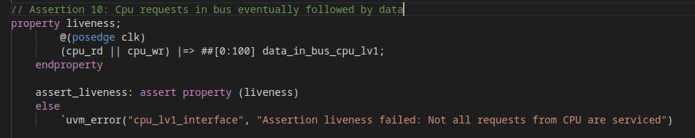

1. **Debugging:**

Error message:

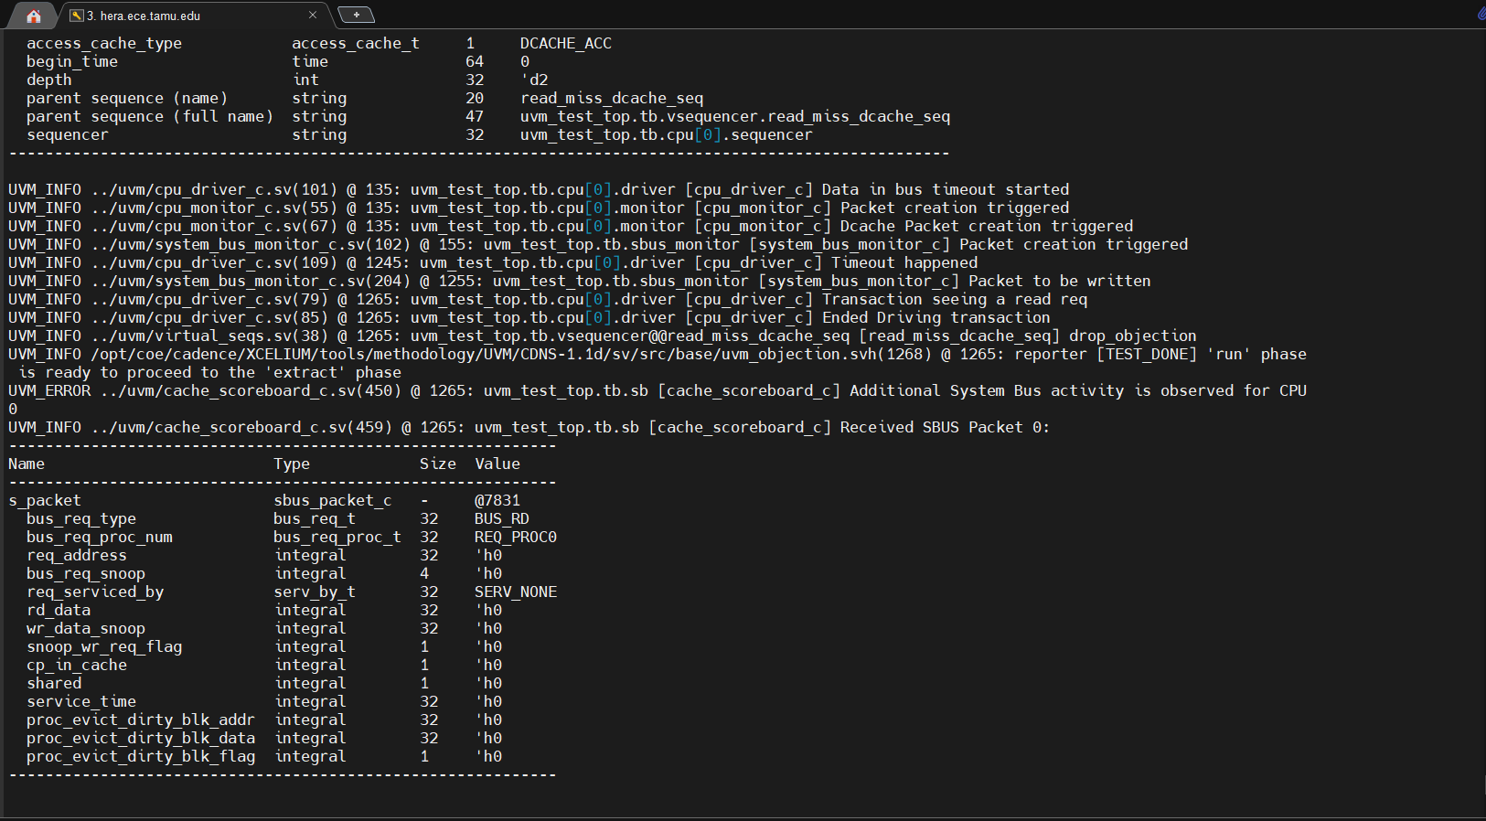

Waveform was observed, and it was found that addr_bus_lv1_lv2 was not being asserted. So the design files were checked for address bus assignments.

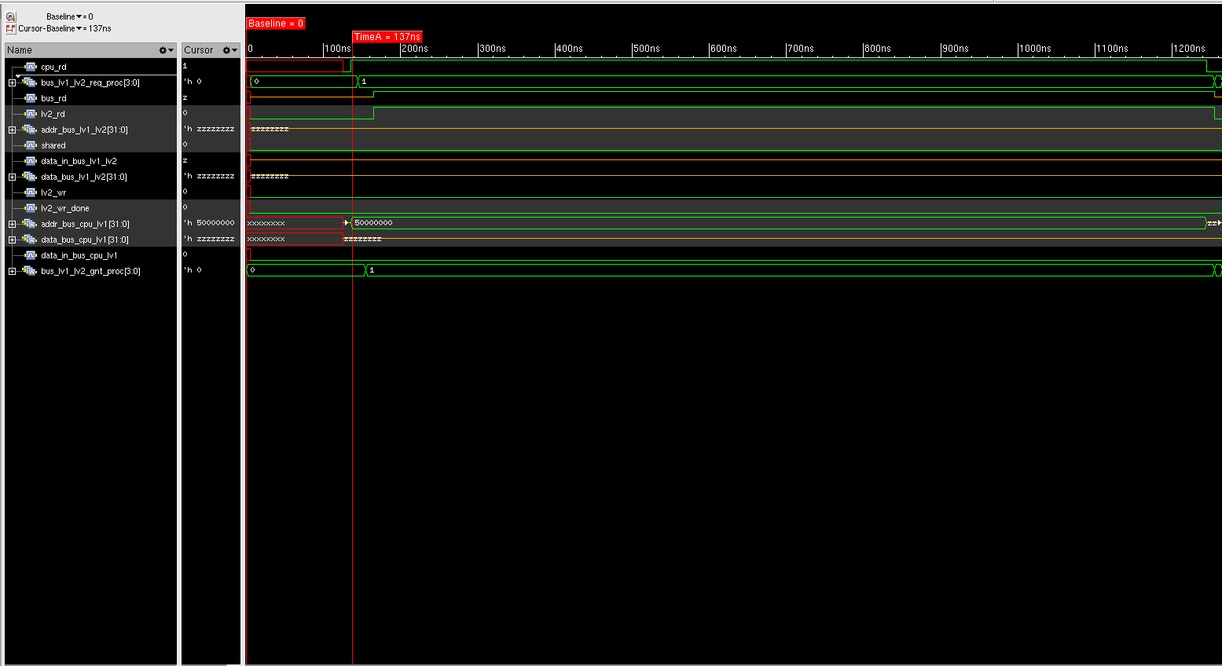

1. **Erroneous RTL file name**

main_func_lv1_dl.sv

1. **Lines of RTL file responsible for the bug (mention the line numbers and lines of the bug)**

104. assign addr_bus_lv1_lv2 = data_bus_lv1_lv2_reg;

1. **Corrected RTL code (only mention the corrections)**

104. assign addr_bus_lv1_lv2 = addr_bus_lv1_lv2_reg;